A.PUSHPANJALI 2303A54050 B-47B
Lab 1
Assignment Number 1.3

TASK:1
PROMPT: Generate a Python program that asks the user for a number and prints of the Fibonacci sequence up to that number, and without using any functions
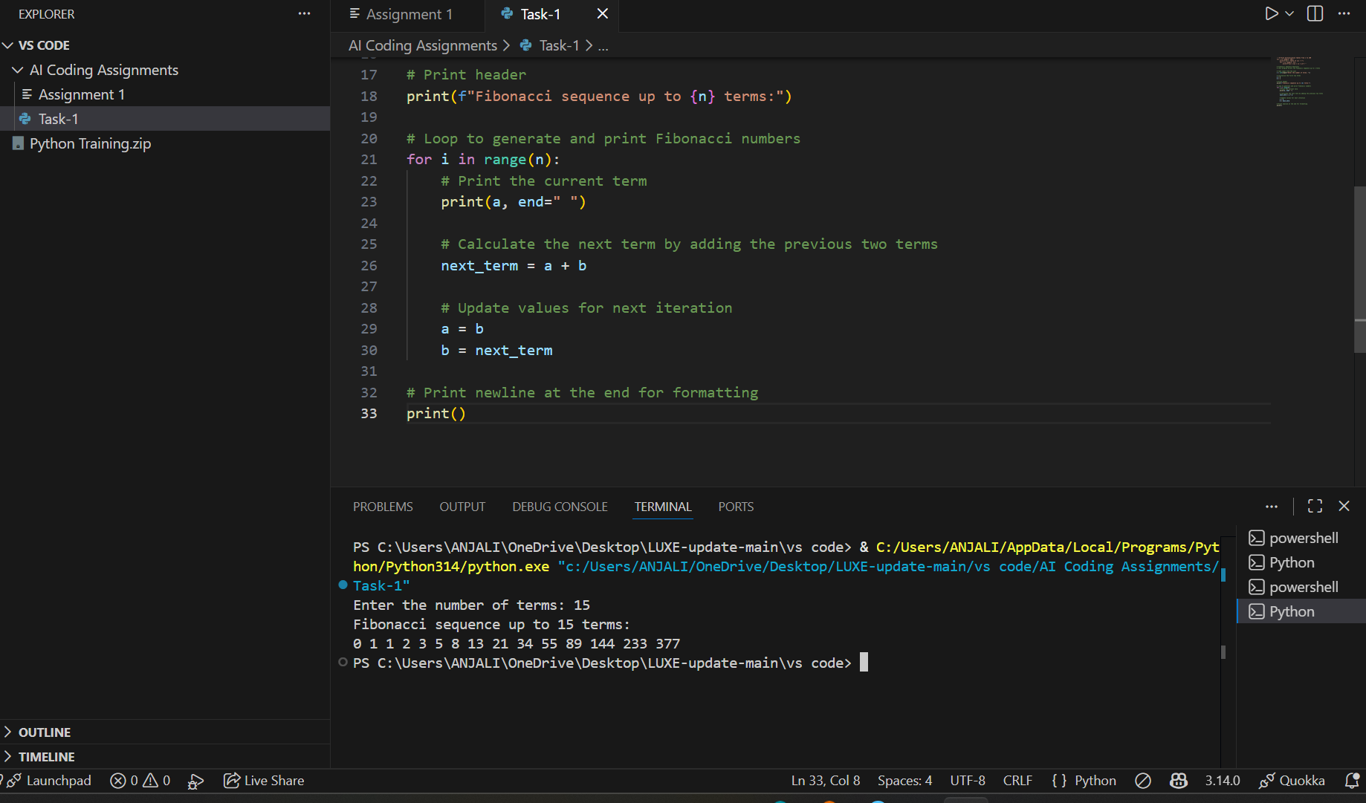

TASK:2
PROMPT: Optimize this code. Remove unnecessary variables, simplify loops, reduce redundant calculations.
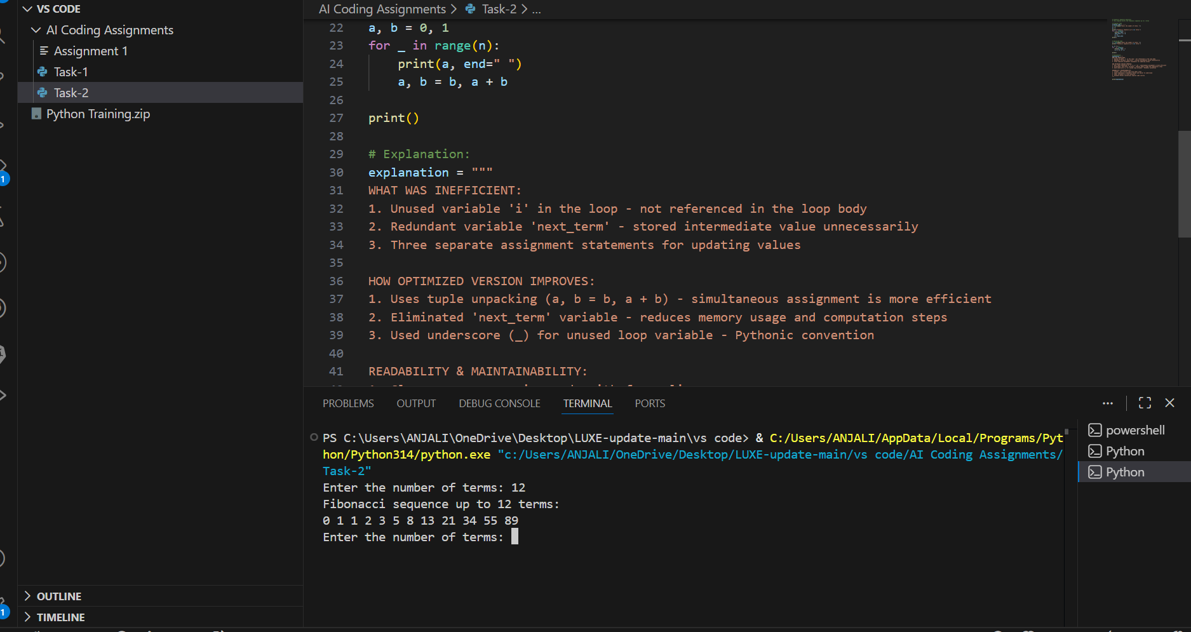

TASK:3
PROMPT: Write a Python program that uses a function to print the Fibonacci sequence and asks the user for a number
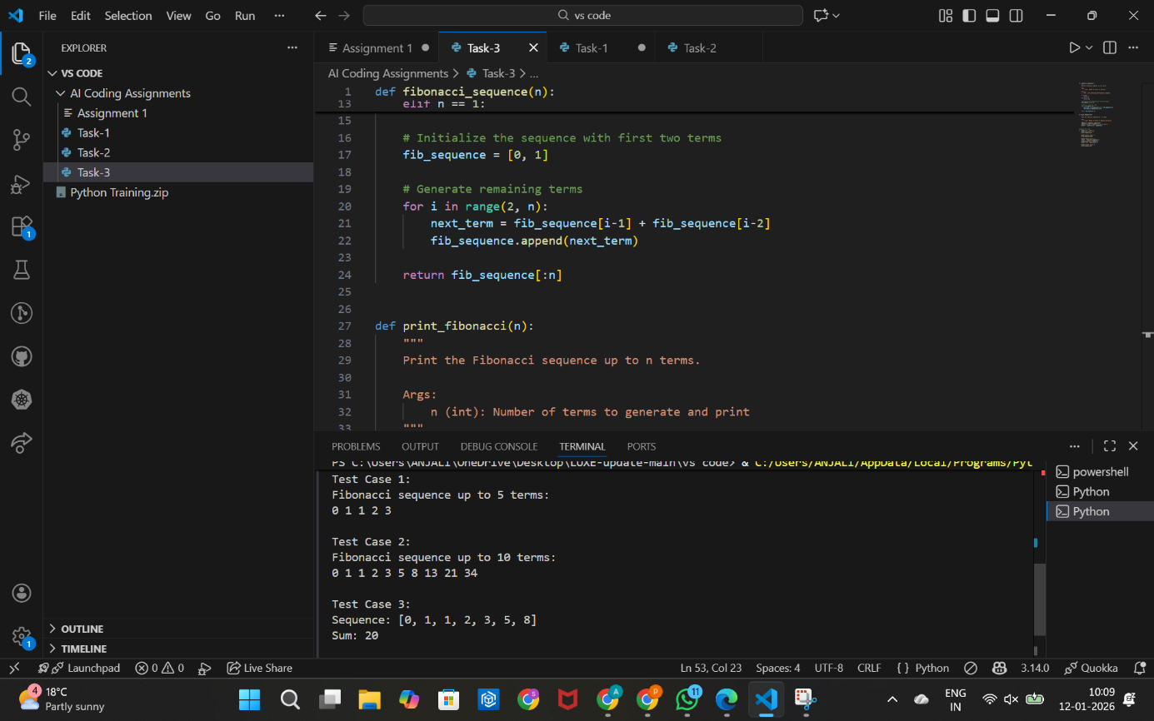

TASK:4
PROMPT: Compare Fibonacci code written without Functions and with functions
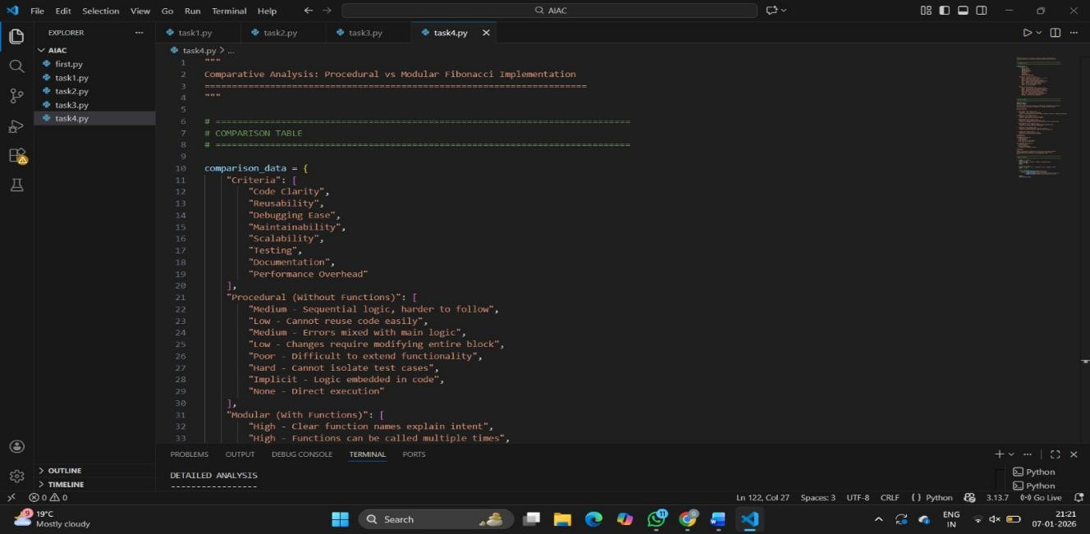
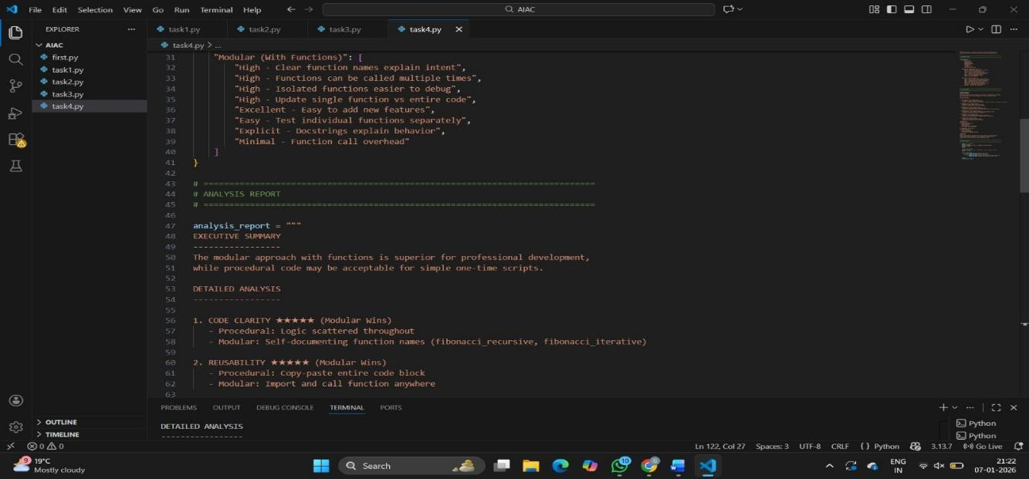
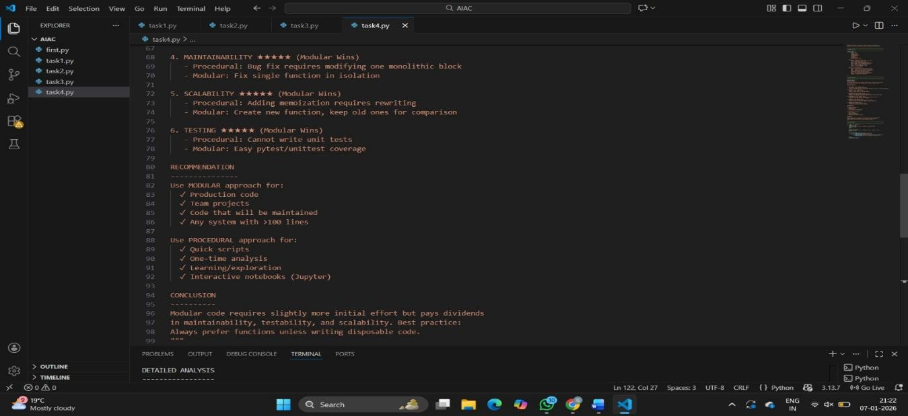

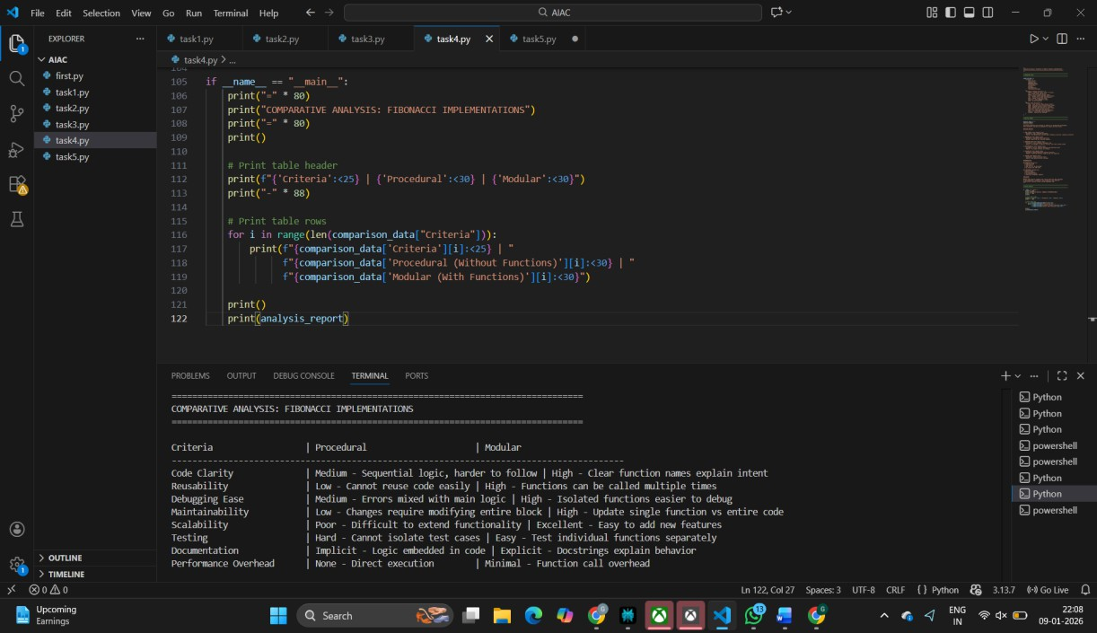

TASK:5
PROMPT: Write an iterative Fibonacci implementation, recursive Fibonacci implementation compare their time complexity, performance for large n.
